3. Networking Devices and Transmission Media
Learning Outcomes
- Introduction to various networking devices and tools
- Introduction to Transmission media
- Introduction to Bounded media, its advantages, disadvantages, its types and applications
- Introduction to Unbounded media, its advantages, disadvantages, its types and applications
3.1 Introduction to various Networking devices and Tools
In today's interconnected world, networks are the foundation of communication, enabling the exchange of information across devices, organizations, and geographies. Networking devices and tools play a crucial role in building, managing, and troubleshooting these networks, ensuring seamless connectivity and performance.
Networking devices such as routers, switches, and access points are the hardware components that facilitate data transfer and communication between systems. Complementing these are various tools—both software and hardware—used to monitor, analyze, and maintain network health and security.
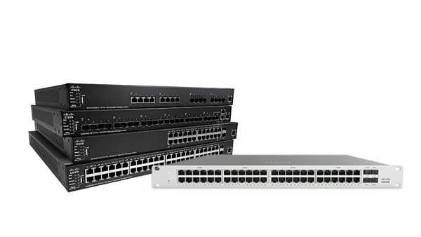
Networking Devices
Router:
A router is a networking device that connects multiple networks and directs data packets between them, acting as a traffic manager for data traveling across the internet or a local network. It operates primarily at the Network Layer (Layer 3) of the OSI model, using IP addresses to determine the most efficient path for data to reach its destination. Routers are commonly used to connect home or business networks to the internet, enabling devices within the network to communicate externally. Modern routers often come with built-in features like Wi-Fi access points for wireless connectivity, firewalls for security, and network management tools for user control.
Switch:
A switch is a device used in a local network to connect multiple devices, like computers and printers, allowing them to communicate with each other. Operating at the Data Link Layer (Layer 2) of the OSI model, a switch uses MAC addresses to identify devices and forward data only to the intended recipient, rather than broadcasting it to all connected devices as a hub would.. This makes the network faster and more efficient by reducing unnecessary traffic. Switches are essential for building reliable and high-performing networks in homes, offices, and larger organizations.
Hub:
A hub is a basic device that connects multiple devices in a network, so they can communicate. Hubs operate at the Physical Layer (Layer 1) of the OSI model and are less efficient compared to switches. It sends the same data to all devices, even if only one needs it, which can slow down the network. Hubs are simple and affordable but are less efficient compared to switches, which send data only to the right device.

Modem:
A modem is a device that connects your home or office network to the internet. It works by converting the digital signals from your devices into analog signals for transmission over phone or cable lines, and vice versa. Without a modem, your devices wouldn’t be able to communicate with your internet service provider (ISP). Modern modems are often combined with routers in a single device to provide internet access and network connectivity.
Bridge:
A bridge is a device that connects two or more separate networks and allows them to function as one. It works by filtering traffic and forwarding only the necessary data between the networks. Bridges are commonly used to reduce congestion in a network and improve performance by dividing it into smaller, manageable segments.
A bridge is used to connect two separate local area networks (LANs) in an office building. For instance, if one department is on the first floor and another is on the second floor, a bridge can connect their networks, allowing employees on both floors to share resources like printers or files seamlessly.
Repeater:
A repeater is a device used to extend the range of a network by amplifying and retransmitting the signal. It takes a weak signal, strengthens it, and sends it further along the network, helping to eliminate dead zones. Repeaters are especially useful in large areas where signals weaken due to distance or obstacles like walls.
It is used in a large home to extend the Wi-Fi signal to distant rooms. For example, if your router is in the living room but the signal is weak in the upstairs bedroom, a repeater placed in between can amplify the signal, ensuring reliable internet access throughout the house.

Networking Tools:
Networking tools are software or hardware used to manage, monitor, diagnose, and troubleshoot computer networks. These tools help network professionals ensure the network operates efficiently, securely, and without issues. Networking tools serve various purposes such as testing connectivity, measuring performance, configuring devices, and resolving network problems.
Examples include:
Physical tools: Like cable testers, crimping tools, and punch-down tools, used to build and maintain network connections.
Software tools: Like network analyzers, IP scanners, and performance monitoring tools, which are used to monitor network traffic, detect faults, and optimize network configurations.
In essence, networking tools are essential for maintaining the health of a network, diagnosing problems, ensuring security, and enhancing performance.
Transmission Media
Transmission media refers to the physical or wireless pathways through which data is transmitted between devices in a network. It serves as the foundation for communication by enabling the transfer of information in the form of electrical signals, light pulses, or electromagnetic waves
There are two main types of transmission media
-Wired (Guided or Bounded) media
-Wireless(Unguided or unbounded) media

Bounded Media
Guided media, also known as wired or bounded media, refers to the transmission medium where data is transmitted through physical cables or wires. The data signals are guided along a specific path, making them less susceptible to interference and more secure compared to wireless media. Guided media is widely used for both short and long-distance communication
Types of Bounded Media
Twisted Pair Cable
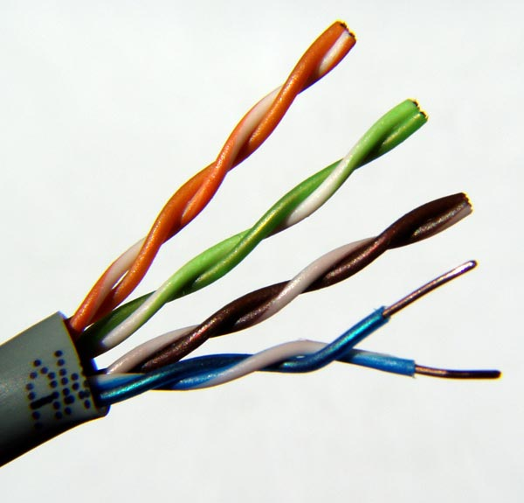
Twisted pair cables consist of two insulated copper wires twisted together to minimize interference and are commonly used in telephone lines and local area networks (LANs). They are cost-effective but have limited bandwidth and distance capabilities.

Coaxial Cables
Coaxial cables, featuring a central copper conductor surrounded by insulation and shielding, provide higher resistance to noise and are widely used for cable TV and broadband internet. They offer better performance than twisted pair cables but are bulkier and more expensive.
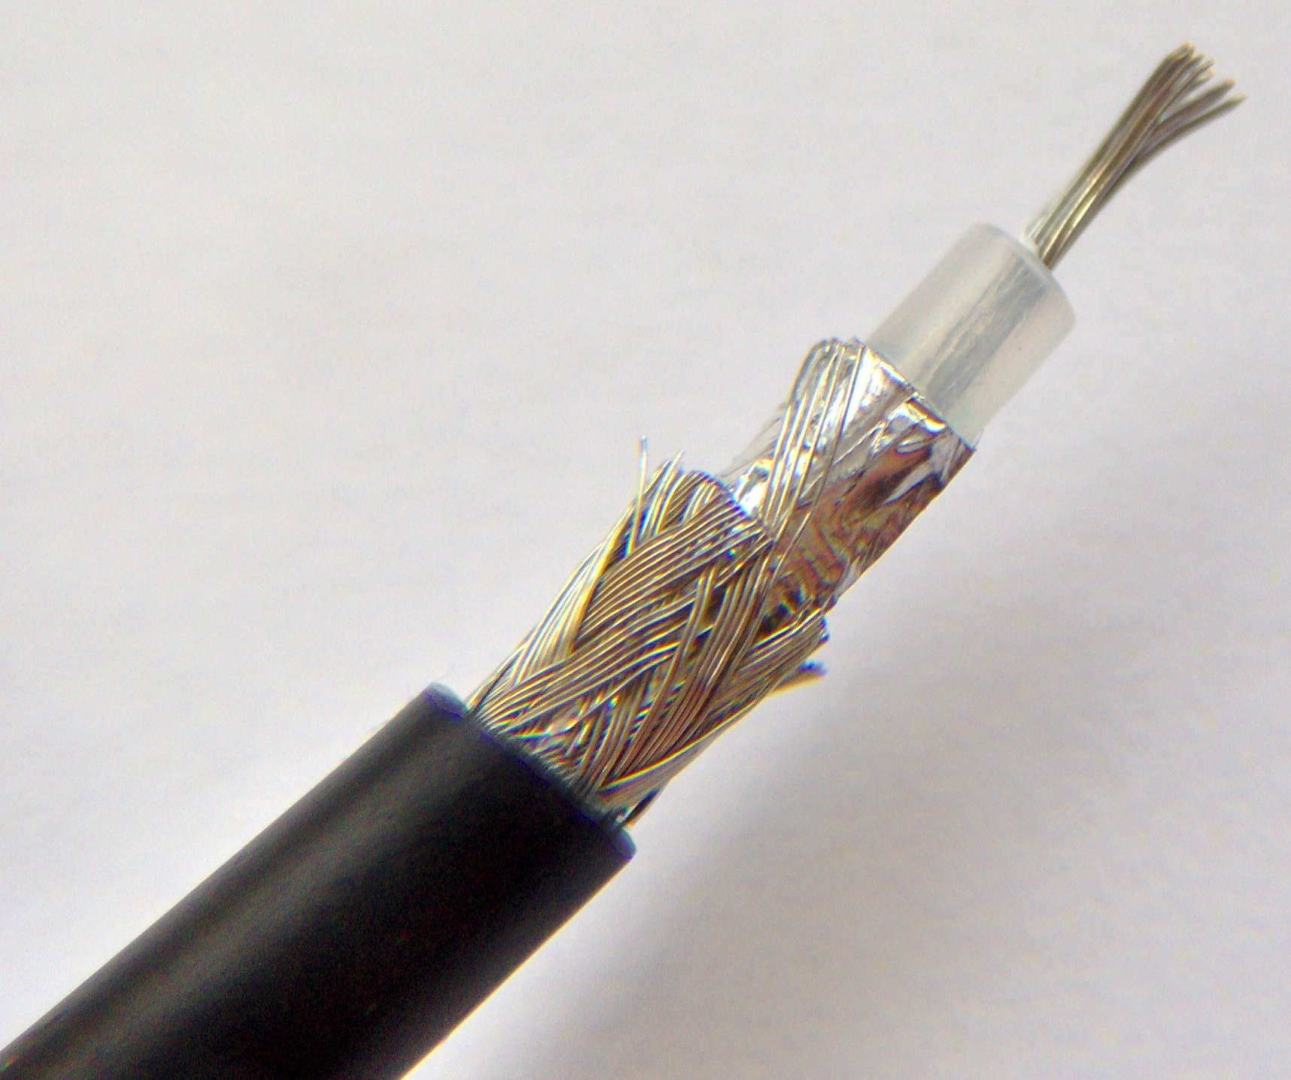

Fiber Optic Cable
Fiber optic cables are the most advanced type, using thin strands of glass or plastic to transmit data as light pulses. They support extremely high bandwidth and long-distance communication while being immune to electromagnetic interference, making them ideal for high-speed internet and telecommunications.
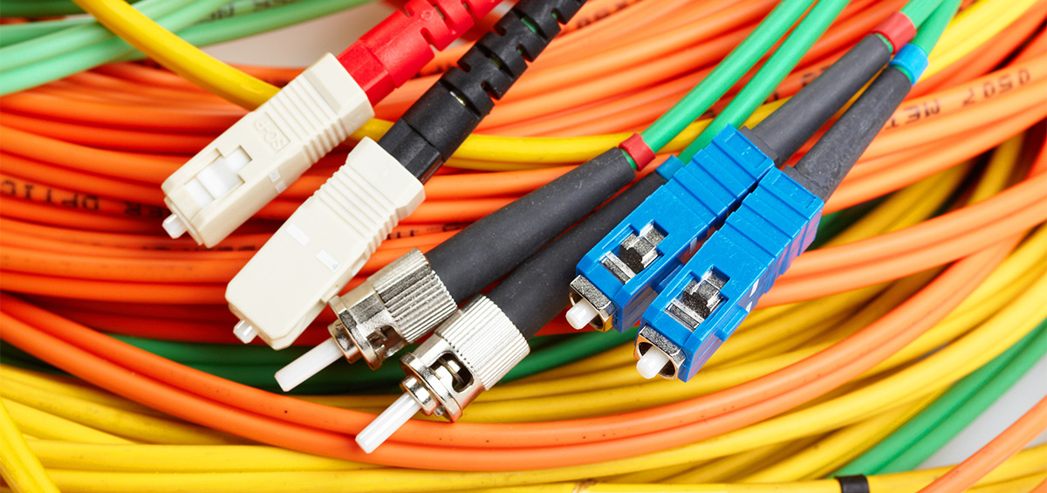

Advantages
- High Security: Data travels through physical cables, making it less susceptible to interception compared to wireless media.
- Reduced Interference: Guided media is shielded from external electromagnetic interference, ensuring reliable communication.
- High Speed and Bandwidth: Especially in fiber optic cables, which can transmit large amounts of data over long distances at high speeds.
- Reliability: Guided media provides a consistent and stable connection, ideal for critical systems like data centers and corporate networks.
- Cost-Effective (for Short Distances): Twisted pair cables, in particular, are affordable and easy to install for small-scale networks.

Disadvantages
- Limited Mobility: Devices must remain physically connected, restricting movement and flexibility compared to wireless communication.
- High Installation Cost (for Long Distances): Deploying cables over large areas, especially fiber optic cables, can be expensive and labor-intensive.
- Susceptible to Physical Damage: Cables can be damaged due to wear and tear, environmental conditions, or accidents, potentially disrupting communication.
- Limited Scalability: Adding new devices or extending the network often requires additional cabling, which can be cumbersome.
- Bulky and Difficult to Handle: Coaxial and fiber optic cables are heavier and more challenging to install and maintain compared to simpler wireless setups.
Applications:
- Local Area Networks (LANs): Twisted pair cables and fiber optic cables are widely used in offices, schools, and homes to connect computers, printers, and other devices within a limited area.
- Telephone Systems: Twisted pair cables are commonly used in landline telephone networks for voice communication.
- Cable Television (CATV): Coaxial cables are extensively used to deliver cable TV signals from providers to homes and businesses.
- Broadband Internet: Fiber optic cables are increasingly used to provide high-speed internet connections, enabling fast downloads, streaming, and online gaming.
- Data Centers: Fiber optic cables are critical in data centers for connecting servers, storage systems, and network devices due to their high bandwidth and low latency.
- Industrial Control Systems: Guided media, especially fiber optics, is used in industries to ensure reliable communication between control systems and machinery in environments with high electromagnetic interference.
- Security Systems: Coaxial and twisted pair cables are used for connecting CCTV cameras and other surveillance systems for secure data transmission.
- Long-Distance Communication: Fiber optic cables are employed in submarine cables that connect continents, enabling high-speed, long-distance communication across the globe.

Unbounded Media
Unbounded media, also known as wireless or unguided media, refers to the transmission medium where data is transmitted without using physical cables or wires. Instead, it relies on electromagnetic waves to carry data through air, vacuum, or water. Unbounded media provides flexibility and mobility, making it suitable for applications where physical connections are impractical.

Types:
Radio Waves:
Radio waves are widely used for long-distance communication as they can penetrate walls and buildings, making them suitable for mobile networks, Bluetooth, and AM/FM radios.

Microwaves:
Microwaves, which require a clear line of sight, are used for point-to-point communication in applications like satellite systems and TV broadcasting.

Infrared Waves:
Infrared waves are limited to short-range communication and are commonly found in devices like TV remotes and wireless keyboards.

Satellite Communication:
Satellite communication involves sending signals from Earth to satellites and relaying them to the intended destination, enabling applications like GPS, satellite internet, and weather monitoring.

Advantages:
- Mobility: Enables communication between moving devices without physical connections.
- Ease of Installation: No need for laying cables, making it faster and cheaper to deploy.
- Wide Coverage: Suitable for long-distance and global communication.
- Flexibility: Ideal for areas where cable installation is impractical, such as remote locations.
Disadvantages:

- Interference: Prone to electromagnetic interference from other signals and environmental factors.
- Security Risks: Easier to intercept data compared to guided media, requiring strong encryption.
- Reliability: Signal quality can be affected by obstacles, weather conditions, and distance.
- Bandwidth Limitations: Certain types of wireless communication have limited bandwidth.
Applications:
Unbounded media, or wireless communication, is extensively used in a variety of applications due to its flexibility and mobility:

- Mobile Communication: Enables voice and data transmission for mobile phones through cellular networks using radio waves.
- Wi-Fi Networks: Provides wireless internet access in homes, offices, and public spaces, connecting devices without physical cables.
- Satellite Communication: Used for GPS navigation, satellite TV, weather forecasting, and global internet coverage.
- Broadcasting: Radio waves and microwaves are used for radio and television broadcasting to reach wide audiences.
- Remote Sensing: Satellites and other wireless systems gather data for environmental monitoring, disaster management, and mapping.
- Bluetooth Technology: Facilitates short-range communication between devices like headphones, keyboards, and smartphones.
- IoT (Internet of Things): Wireless communication connects smart devices in homes, industries, and healthcare for automation and monitoring.
- Military and Defense: Unbounded media is used for radar systems, secure communication, and surveillance in military applications.
- Drone Communication: Wireless technologies control drones for surveillance, delivery, and photography.
- Remote Access and Control: Allows controlling devices remotely, such as in smart homes, robotics, and industrial automation.

Transmission Modes
Transmission modes also known as communication modes, are methods of transferring data between devices on buses and networks designed to facilitate communication. They are classified into three types: Simplex Mode, Half-Duplex Mode, and Full-Duplex Mode.

- Simplex Mode
In Simplex mode, the communication is unidirectional, as on a one-way street. Only one of the two devices on a link can transmit, the other can only receive. The simplex mode can use the entire capacity of the channel to send data in one direction.
Example: Keyboard and traditional monitors. The keyboard can only introduce input, the monitor can only give the output.

- Half-Duplex Mode
In half-duplex mode, each station can both transmit and receive, but not at the same time. When one device is sending, the other can only receive, and vice versa. The half-duplex mode is used in cases where there is no need for communication in both directions at the same time. The entire capacity of the channel can be utilized for each direction.
Example: Walkie-talkie in which message is sent one at a time and messages are sent in both directions.

- Full-Duplex Mode
In full-duplex mode, both stations can transmit and receive simultaneously. In full duplex mode, signals going in one direction share the capacity of the link with signals going in another direction, this sharing can occur in two ways:
- Either the link must contain two physically separate transmission paths, one for sending and the other for receiving.
- Or the capacity is divided between signals traveling in both directions.
Full-duplex mode is used when communication in both directions is required all the time. The capacity of the channel, however, must be divided between the two directions.
Example: Telephone Network in which there is communication between two persons by a telephone line, through which both can talk and listen at the same time.

